How long should I spend on each lesson or stage of the program?
Using the iCanStudy program
Back to Learning Support
General rules for progression
- Do not advance if you have more than 3 items in your task list that you can act on or practice.
- Do not advance if you are unable to do the current set of techniques to at least 80% consistency and accuracy (equivalent to moderate conscious competence).
How to know if you're ready
You are ready to move on to the next set of techniques if you:
- Feel comfortable with your current techniques
- Have practised them under varying challenges and subjects
Under no circumstances should you progress if you:
- Have not practised the techniques
- Have more than 3 new techniques that are not yet at moderate conscious competence
Identifying your level of conscious competence
Competence level | Signs
Unconscious incompetence | You are not even aware of where your mistakes are. This is often when you have not practised the technique (or do not even know about a technique). You have yet to discover mistakes.
Low to moderate conscious incompetence | You have discovered some mistakes while practising but have not been successful at overcoming them yet.
High conscious incompetence | You have discovered several mistakes with multiple attempts at trying to overcome them. You have not been successful yet, but the types of adjustments and experiments you are making are much more targeted and marginal.
Low conscious competence | You are able to do the technique correctly. Your consistency and accuracy are poor. You still occasionally discover new mistakes when challenging yourself in different contexts.
Moderate conscious competence | You are able to do the technique correctly with reasonable consistency and accuracy. It is starting to become slightly more comfortable.
High conscious competence | You are able to do the technique correctly with high consistency and accuracy. You can achieve this with reasonably low levels of effort. It is very comfortable.
Unconscious competence | You are able to do the technique correctly as a new habit. There is still effort needed to think and process, which is part of the technique, but there is no extra effort needed to simply apply the technique correctly.
Common questions
What if it takes too long to progress?
Rate of improvement directly depends on:
- Rate of experimentation
- Rate of reflection
The faster you can identify mistakes, experiment on ways to overcome them, and reflect on your experiment, the faster you will be able to progress. The first thing to examine is: "is my rate of experimentation and reflection adequate?".
It is rare for someone to progress slowly when they have appropriate experimentation and reflection frequency.
Furthermore, consider the following:
- There is no alternative. Learning too many techniques at once is guaranteed to cause overload and technique failure. This wastes more time.
- It is impossible to gain new skills without going through the process of experimentation and reflection. Delaying this process only delays skill acquisition.
- Your rate of development through our program is incomparably faster than for the general population. Many of the skills taught only in the High-yield phase are beyond what the majority of learners gain in their entire lifetimes. Dr Justin Sung took 10 years of constant experimentation to develop some of these systems.
- Many of the changes (especially in the Growth phase) are about cognitive retraining. This involves changing habits that may have been present for several years. Unlearning old habits and reinforcing new ones takes time.
If it were easy, fast or effortless, everyone would already do it.
On the other hand, relatively few people are willing to go through this effort to achieve these results, meaning the transformation you achieve will remain uncommon and competitive.
I feel like each technique is not too difficult. Can I learn them in batches of more than 3?
It is not advisable to learn more than 3 techniques at a time (at most) because each technique in a system influences each other.
Even if each technique is simple to use by itself, when they are integrated into a cohesive system, the complexity of using them all correctly multiplies. More variables are introduced into the system.
For example, imagine a spinning top like the one shown below:
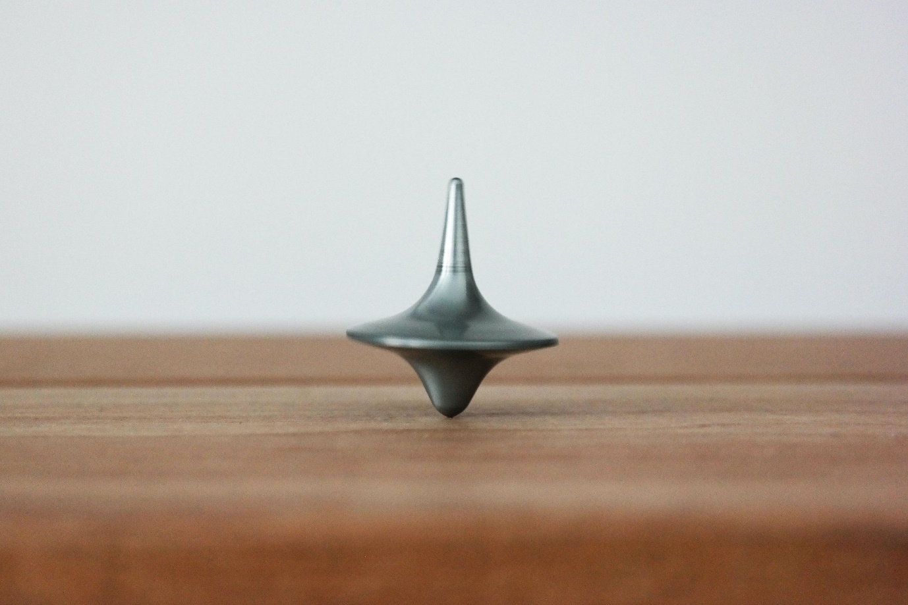
It is easy to predict how it will spin, slow down, and eventually fall.
However, if we were to introduce another spinning top next to it, it becomes almost impossible to predict when they will clash, how they will clash, and how they will bounce after clashing. Now imagine three spinning tops.
You can see how the complexity of the overall system becomes significantly higher, even though each piece is relatively predictable in isolation.
The most important part about building an efficient learning system is compounding your gains.
As long as you can continue to build on your system and enhance it gradually, you will win. One of the most difficult issues to try and solve is when a system becomes so complicated and entangled that when problems arise, it becomes impossible to identify where the root cause is. This makes problem-solving and improving significantly more challenging and often requires the extended attention of a specialist coach.
So how long should I spend in terms of days or weeks?
The actual time you should spend on each technique depends on how much you practice, experiment and reflect. It also depends on the quality of your experiment and reflection.
Therefore, you should first ensure that you have:
- Appropriate experiments that allow compounding marginal gains (as per the conscious competence model in alignment with what we teach about skill development)
- High-quality reflection (in alignment with our guidelines for proper Kolb's)
- Sufficient frequency of practice and experiments to carry momentum
If you fulfill these criteria, you expect to spend:
- 5 to 10 hours of practice per technique in High-yield phase
- 20 to 30 hours of practice per technique in Growth phase
Stages with more techniques naturally require more time. As your system grows and becomes more personalised, the amount of practice can become longer as mistakes are less obvious and it requires greater challenges to identify weaknesses.
The table below outlines some general timelines based on our observation of thousands of previous successful learners.
Scenario | High-yield phase completion time | Growth phase completion time
2 to 3 hours of theory online per week. 30 hours of practice and application during self-study sessions per week. | 4 to 6 weeks | 4 to 7 months
2 to 3 hours of theory online per week. 15 hours of practice and application during self-study sessions per week. | 6 to 12 weeks | 6 to 10 months
2 to 3 hours of theory online per week. 5 hours of practice and application during self-study sessions per week. | 8 weeks to 4 months | 12 to 20 months
Note: changes to theory time per week have minimal effect on completion and mastery time. More than 4 or 5 hours of theory per week generally has a detrimental effect on completion due to overload.
What is an ideal theory vs. practice schedule for completing the program?
An appropriate progression would be as follows.
Theory: Learn 2 or 3 new techniques over the weekend
Practice: Spend 15 to 30 hours during the following week or more to apply these techniques during self-study sessions.
Reflection: Reflections on techniques and formulations of new experiments should occur daily, if possible, or at least 3 times per week. Reflection sessions can be boxed to a maximum of 30 or 45 minutes, depending on availability.
As the quality of reflection is limited by each prior stage of Kolb's, spending longer than 45 minutes is unlikely to have significant benefits. For example, if it takes 30 minutes just to complete the 'reflection' stage, it indicates a lack of self-awareness and reflective ability. Therefore, the quality of the abstraction and experiment will be limited. Over time, self-awareness and reflection will improve, allowing this step to be completed to a high quality in just 10 minutes, leaving ample time.
Feedback: Feedback on work should be sought at least weekly.
With this schedule, you should be able to reach moderate conscious competence for most techniques within 2 weeks, driving a steady rate of weekly improvement.
If at any point you feel your technique level is declining, especially as your system becomes more advanced, we recommend taking 2 to 4 weeks to consolidate before attempting to add new techniques.

